

**Department of Mechanical Engineering**

**FACULTY OF ENGINEERING AND DESIGN**

**FINAL YEAR MEng PROJECT PLAN AND LITERATURE REVIEW**

*Wave Energy Converter power increase through active control: Fixed gains*

*Carl Selig*

*November 2019*

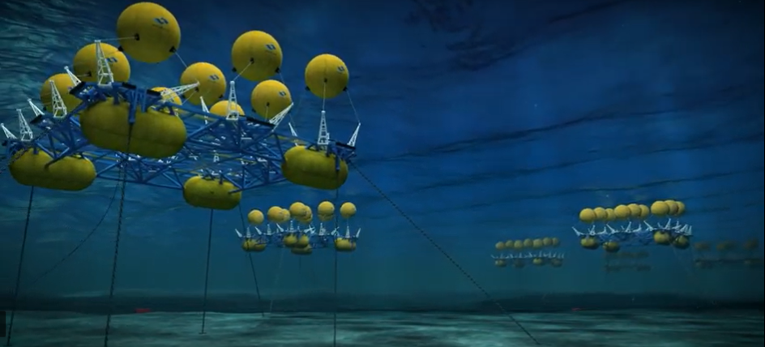

(Marine Power Systems, 2019)

*Supervisor: Dr. Andrew Hillis*

*Assessor: Dr. Zhijin Wang*

# Summary

A project is proposed to develop and investigate the effectiveness of a fixed gain control system strategy for a six degree of freedom submerged Wave Energy Converter (WEC). The WEC is modelled on a product known as WaveSub (Marine Power Systems, 2019) which features a submerged cylindrical buoy with four tethers.

The control system strategy will be evaluated on how much extra power it is able to capture over an optimally damped passive system in a variety of sea states. It must also stay within the physical constraints of the WEC device. This will be evaluated using a pre-established software simulation known as WECsim.

The fixed gain control scheme to be investigated is known as Simple and Effective control and was presented by Ringwood (Fusco & Ringwood, 2013). Ringwood’s work considers a 1 Degree of Freedom (DOF) WEC. Home position drift has been observed in previous work when applying this scheme to 6DOF systems. The cause of this error will be investigated and a conclusion will be reached on the applicability of Simple and Effective Control to 6DOF WECs.

# Introduction and Background

Wave power is a promising renewable energy source that offers advantages over technologies such as solar and wind power. Notably wave power is always available, making it easier to match energy supply and demand. In other words, wave power has a guaranteed base load.

The modern concept of wave power was first proposed in 1974 by Stephen Salter in the form of the so-named Salter duck (Salter, 1974). This device was proposed as an alternative to oil during the 1973 Oil Crisis in the UK. As shown in Figure 1 the Salter duck generates power by having its vane (beak) bobbed by incoming waves. It then transfers this energy to an internal drum.

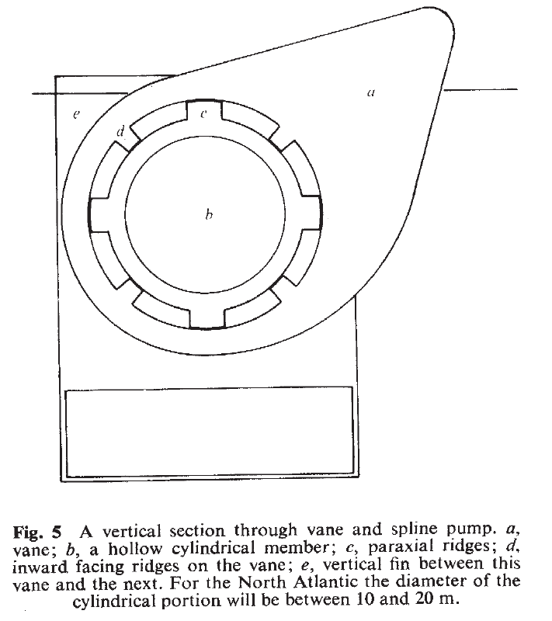

Figure 1: A reproduction of a figure from “Wave Power,” (Salter, 1974). “a. vane; b, a hollow cylindrical member; c, paraxial ridges; d, inward facing ridges on the vane; e, vertical fin between this vane and the next.”

Salter received funding from the UK Department of Energy to set up a laboratory in Edinburgh. Wave power also garnered interest from other British academics, notably David Evans in Bristol who invented the Bristol Cylinder. (Evans, et al., 1979).

Evans also developed theories on the hydrodynamics and efficiency of WECs under idealised conditions (Evans, 1976). His work concerns a one dimensional scenario where waves are modelled as perfect sinusoids that meet the WEC at right angles. This is not the case in nature and thus his claim that 100% extraction of wave energy is possible has never been produced in practice.

Unfortunately, with the conclusion of the Oil Crisis, Salter and Evans found it increasingly difficult to secure funding for their research and none of their devices have been brought to market. In his Review article titled, “Wave energy: Nostalgic Ramblings, future hopes and heretical suggestions,” Salter blames pressure from the nuclear sector and “others [who] set out to destroy what they saw to be a threat,” (Salter, 2016). He then goes on to explain that whilst WECs were initially billed as very simple the reality is significantly more complex.

At the time of writing there have been two WEC projects in the UK that have reached commercialisation. Pelamis from Pelamis Wave Power and Oyster from Aquamarine Systems. (The European Marine Energy Center Ltd., 2019). Figure 2 shows these devices as they were installed. Pelamis 1 was installed in 2004 and became the first WEC to provide power to a National Grid. Pelamis 2 became the first WEC to be purchased by a utility company in 2009. Oyster was installed in 2012. Both devices provided power to the National Grid over the course of their lifetimes.

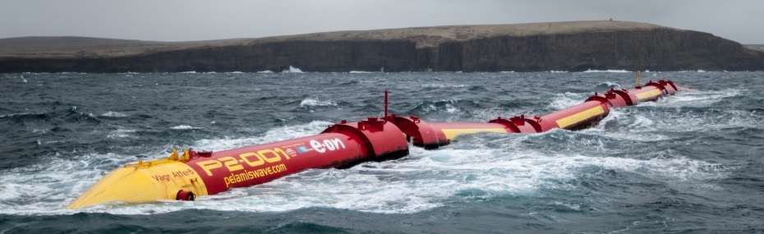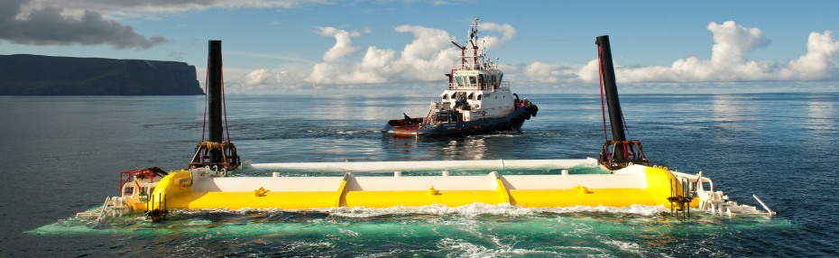

Figure 2: Pelamis 2 [Top] and Oyster [Bottom] as installed at the Billia Croo wave test site in Orkney, Scotland. (The European Marine Energy Center Ltd., 2019)

Similarly to Salter and Evans, both organisations found it difficult to secure funding after their initial funding lapsed. Both companies went into administration a few years after the installation of their WECs. This appears to be a recurring problem in the industry as there have been many other promising WEC projects that have failed to find investors. Examples include Corpower Ocean and Seatricity (The European Marine Energy Center Ltd., 2019).

# Literature review

It appears previous WECs were not economically viable as no WEC project to date has consistently made profit. Investors have also proven unreliable long-term. Barring global economic change there is a need to make WECs more profitable if they are to become a national power source.  
  
One way of increasing the viability of a WEC is to use a control system. By taking the current Wave Excitation Force as an input the power extraction of a WEC can be optimised. In this project an in-development WEC known as WaveSub is used to investigate the effectiveness of fixed gain control schemes for power optimisation.

The WaveSub device consists of a submerged cylindrical float tethered to an underwater platform via 4 cables. The cables drive Power Take Offs (PTOs) that can extract energy from the motion of the float relative to the platform. (Marine Power Systems, 2019)

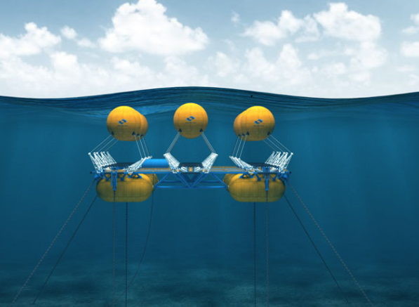

Figure 3: A graphic of an array of 9 WaveSub devices. (Marine Power Systems, 2019). In this project the PTOs will be modelled as cable-drums rather than the arms shown.

A pre-existing simulation environment known as WECSim has been made available by Dr. Andrew Hillis. This simulation was used in various works by Dr. Hillis to compare the power extraction of a Model Predictive Control (MPC) scheme to an, “Optimally tuned, passively damped” system (Hillis, To Appear) (Hillis, et al., To Appear). This approach will be used in this project to assess control system performance.

Many control schemes have been used to increase the power absorption of the WaveSub device and other WECs such as floating-point absorbers (Abdelkhalik, et al., 2017). Of note is a scheme known as, “Simple and Effective,” control proposed by John Ringwood and Francesco Fusco (Fusco & Ringwood, 2013). They claim that this scheme approaches the effectiveness of an MPC scheme whilst being both simpler and more robust.

In these works Model Predictive Control is considered a benchmark. As a computationally cheap

It is a fixed gain control scheme that takes an estimate of Wave Excitation force as an input, filters it uses an Extended Kalman Filter and an adaptive law based on wave peak frequency to evolve an optimal velocity trajectory, and then subjects the WEC PTO to Proportional-Integral control in order that the prime mover tracks the velocity trajerctory. The block-diagram for this scheme is shown in Figure 4.

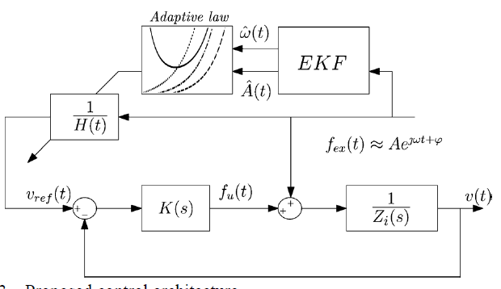

Figure : Reproduction of figure 3 from “A Simple and Effective Real-Time Controller for Wave Energy Converters,” (Fusco & Ringwood, 2013). Shown are the estimated Wave Excitation Force input, ; the Extended Kalman Filter (EKF) and Adaptive law implementation, and finally the Proportional Integral control loop. Wave Excitation Force is estimated as sinusoidal.

The Simple and Effective control scheme therefore offers a significant advantage over more computationally intensive methods. However, these results have only been shown to be true for WECs that are constrained to 1 axis (heave). In unpublished work, Hillis has implemented this control scheme in a 6 Degrees-Of-Freedom (6DOF) system using Internal Model Control. He has observed that the float drifts from its home position over time, eventually violating the device’s constraints. Works from the 2019 EWTEC conference which use alternative tracking control do not exhibit this drift.

The cause of the drift is unknown and represents a novel research subject. There has been comparatively little work on 6DOF WECs compared to planar devices like the Salter duck and Bristol Cylinder. This project will seek to replicate the drift result and will investigate its cause. Ideally the drift could be rectified without the need for additional control loops, retaining the computational simplicity of the scheme.

Estimating the Wave Excitation Force becomes more complex in 6DOF. It is necessary to consider all the forces acting on the float and their modes. Typically, a force vector like this will be represented as a matrix. It may be possible to adapt existing work on Heave only WECs into this format. Nguyen and Tona have presented a detailed account on two methods of Wave Excitation Force estimation (Nguyen & Tona, 2018). Alternately there is a wealth of research available on semi-analytical or computational methods. M. Folley’s book, “Numerical Modelling of Wave Energy Converters” (Folley, 2016) is a modern collection of these methods.

Finally, it is necessary to construct a state-vector for the system. In heave only WECs this is a single variable. For 6DOF WECs the state vector is more complex. Approaches such as Homogeneous Transforms from a fixed reference frame have been used successfully (Hillis, To Appear). However, there are alternate methods which merit investigation. The WaveSub device is a class of cable robot and its position can be represented using Screw Theory. J.P. Merlet’s book “Parallel Robots,” (Merlet, 2006) offers a comprehensive explanation of this method.

# Aims and Objectives

1. Reproduce the work demonstrated in “A Simple and Effective Real-Time controller for Wave Energy Converters” (Fusco & Ringwood, 2013) in the WaveSim Simulink environment (Hillis, To Appear) under Idealised conditions.
2. As above but under Kinematic conditions and a range of sea states.
3. Verify that the Simple and Effective Control scheme results in drift of the float from the home position.
4. Attempt to solve the drift issue using understanding of control theory, Rigid Body Motion, and the system Kinematics.
   1. Alternatively compensate for the drift with an additional position control loop if an analytic solution cannot be found.
5. Investigate alternative control strategies such as:
   1. Model Predictive Control (Hillis, et al., To Appear)
   2. Multi-resonant feedback control (Abdelkhalik, et al., 2017)
   3. Pseudo-spectral Control (Abdelkhalik, et al., 2018)
6. Produce Final Report

# Work Plan

There are 3 broad phases to the project:

1. Reproduction of prior work
2. Solution finding
3. Reporting

## Reproduction of prior work:

The WaveSub device will be modelled in the WECSim environment and the control system will be implemented from scratch. This period will provide experience with the simulation environment and background theory.  
  
The goal of this phase is to reproduce the drift observed by Dr. Hillis in his implementation. Only an Idealised model will be produced in this phase.

## Solution finding

In this phase the model will be extended to account for Kinematic input conditions and a variety of sea states. Adjustments to the modelling of inputs, control parameters, and system constraints will be used to investigate the cause of the drift.

If a solution cannot be found, alternate control methods will be evaluated for their effectiveness. One potential solution is to add an additional control loop to the scheme in Figure 4 and determine whether this significantly impacts computing time and system robustness.

## Reporting

All results will be collected, and a final report will be produced. It is in this phase that a conclusion regarding the possibility of a solution will be decided. The impact of this and similar works on the future of renewable energy will also be considered.

## Methodology

The methodology for this project is best expressed as the sum of its parts:

* Weekly Meetings
  + Weekly meetings with be held with the project supervisor at which current progress will be presented for discussion. These meetings will serve as soft deadlines. Discussion will ensure the project stays on track or that plans can be made if it deviates. Criticism will ensure that academic rigour is maintained.
* Daily logging
  + A daily log will be maintained concerning the approaches that have been used and their parameters. It will also record relevant texts for future study and to be included in the final report’s Bibliography.
* Self-evaluation
  + At key points throughout the project a self-evaluation will be performed on current findings. This will be discussed with the supervisor and will ensure the predicted timescale is respected.
* Collaboration
  + There are other students in the university who will be performing projects in this area. Group meetings will be proposed at which different perspectives can be shared.

## Deliverables

* A reproduction of the Simple and Effective Control scheme (Fusco & Ringwood, 2013) in the WECSim environment on the WaveSub device.
  + In phase 1: An Idealised input scenario (perfect Wave Excitation force knowledge, simple waves).
  + In phase 2: A kinematic input scenario (estimated Wave Excitation forces, a variety of sea states).
* Well-documented solution attempts as recorded in the daily log.
* The full code for the project. The language will be MATLAB, specifically the Simulink plug-in.
* A full project report not exceeding 12,000 words.

# Predicted Timescale

GANTT CHART HERE

## Risk mitigation

|  |  |
| --- | --- |
| **Risk** | **Mitigation** |
| Float drift cannot be reproduced. | Dr. Hillis has agreed to share his original code in this scenario so that a comparative study can be done. |
| No solution to the drift problem, even partial, can be found. | There are two alternate topics that can produce useful research. The Simple and Effective control strategy could be modified with a positional control loop, or alternate control strategies can be evaluated, adding to the work performed in (Hillis, To Appear) |
| Significant project drift | Routine meetings and self-evaluation will help identify this problem early, at which point a revised timescale can be implemented. |
| Loss of work | Backups will be made throughout the project which will be stored on a USB, on the university servers, and on GitHub. |
| Poor mental or physical health. | I have health concerns for which I am receiving treatment. I will co-ordinate with Student Services and follow all medical instructions. |

# References

Abdelkhalik, O. et al., 2018. Control of three degrees-of-freedom wave energy converters using pseudo-spectral methods.. *ASME. J. Dyn. Sys., Meas., Control,* July, 140(7), p. 074501 (9 pages).

Abdelkhalik, O. et al., 2017. Multiresonant Feedback Control of a Three-Degree-of-Freedom Wave Energy Converter. *IEEE TRANSACTIONS ON SUSTAINABLE ENERGY,* October, 8(4), pp. 1518-1527.

Evans, D., 1976. A theory for wave-power absorption by oscillating bodies. *Journal of Fluid Mechanics,* 77(1), pp. 1-25.

Evans, D., Jeffrey, D., Salter, S. & Taylor, J., 1979. Submerged cylinder wave energy device: theory and experiment. *Applied Ocean Research,* 1(1), pp. 1-12.

Folley, M., 2016. *Numerical Modelling of Wave Energy Converters.* s.l.:Academic Press.

Fusco, F. & Ringwood, J., 2013. A Simple and Effective Real-Time controller for Wave Energy Converters. *IEEE Transactions on Sustainable Energy,* January, 4(1), pp. 21-30.

Hillis, A. J. et al., To Appear. Active control for multi-degree-of-freedom wave energy converters with load limiting.

Hillis, A., To Appear. *The impact of modelling and prediction errors on the performance of optimally controlled multi-DOF wave energy converters,* Bath: s.n.

Marine Power Systems, 2019. *Wave Sub.* [Online]   
Available at: https://marinepowersystems.co.uk/wavesub/  
[Accessed 24 November 2019].

Merlet, J.-P., 2006. *Parallel Robots.* 2 ed. s.l.:Springer Science & Business Media.

Nguyen, H. & Tona, P., 2018. Wave Excitation Force Estimation for Wave Energy Converters of the Point-Absorber Type. *IEEE TRANSACTIONS ON CONTROL SYSTEMS TECHNOLOGY,* 26(6), pp. 2173-2181.

Salter, S., 1974. Wave Power. *Nature,* Volume 249, p. 720 724.

Salter, S., 2016. Wave energy: Nostalgic Ramblings, future hopes and heretical suggestions. *J. Ocean Eng. Mar. Energy,* 2(4), pp. 399-428.

The European Marine Energy Center Ltd., 2019. *Wave Clients.* [Online]   
Available at: http://www.emec.org.uk/about-us/wave-clients/  
[Accessed 11 November 2019].